AWS WAF
AWS WAF (Web Application Firewall) is a managed security service designed to
protect web applications and APIs from common web exploits, bots, and
malicious traffic. It operates at Layer 7 (the application layer) of the OSI model.
What AWS WAF Does
It acts like a protective filter between the internet and your application. You
define rules, and AWS WAF decides whether to allow, block, or monitor incoming
HTTP/HTTPS requests.

Create EC2 instance
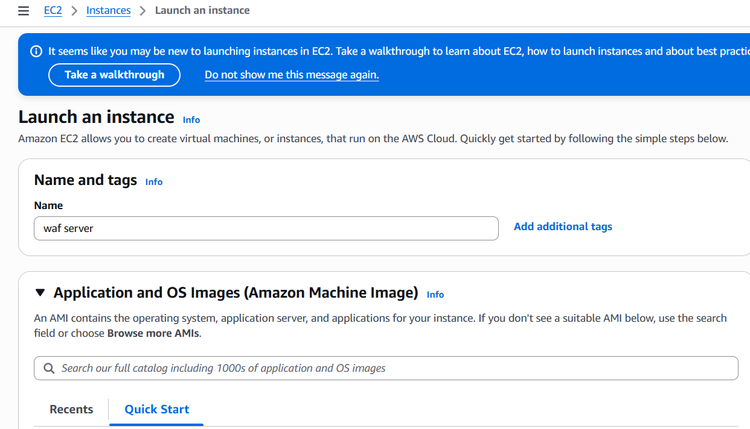
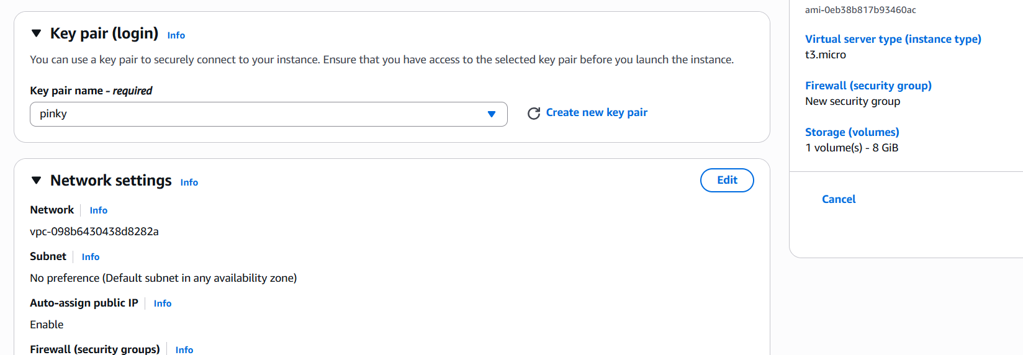
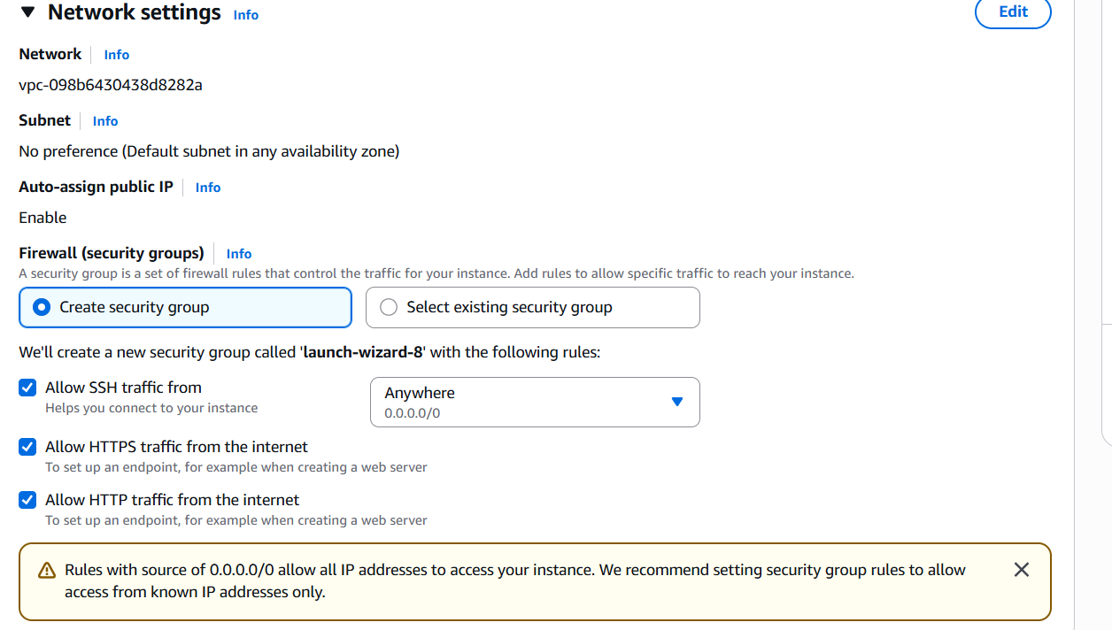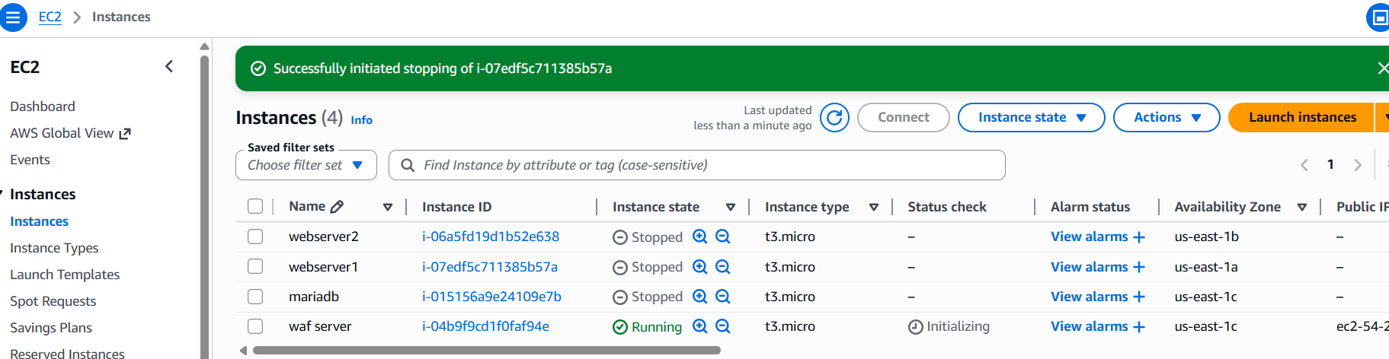connect the instance
Install httpd
Yum install httpd -y

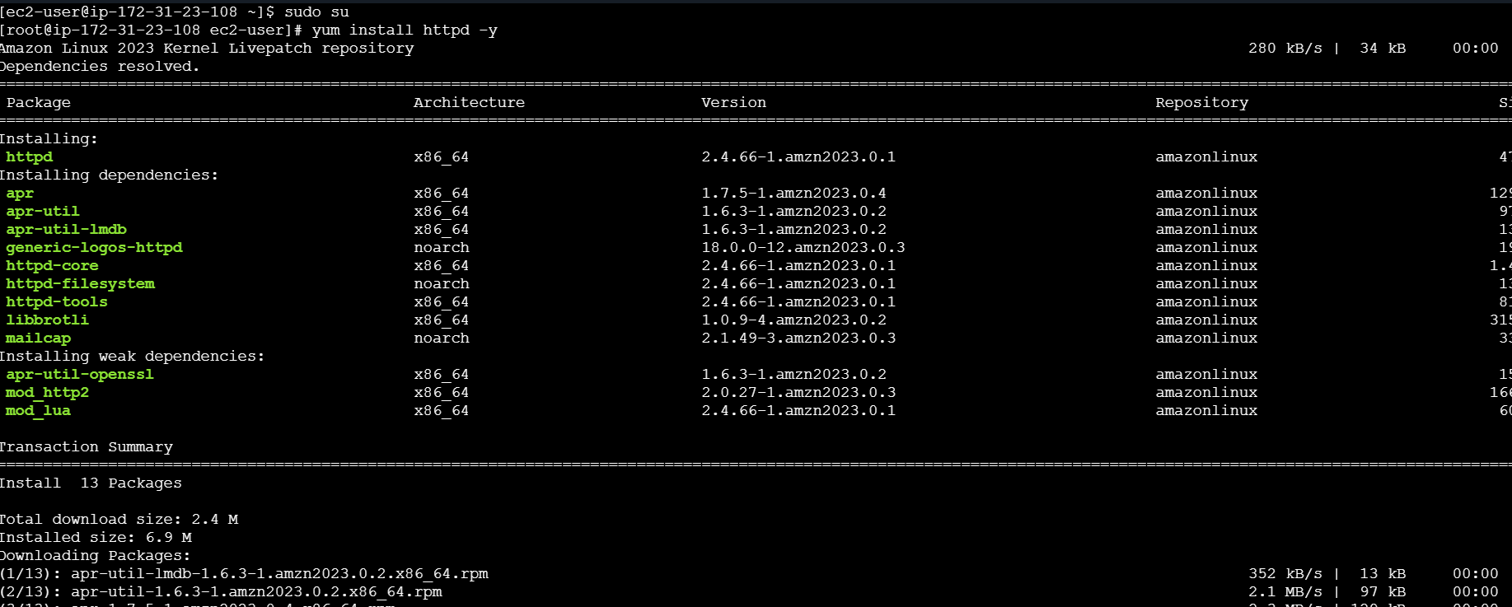
To check the server is running or not
Systemctl enable httpd
Systemctl start httpd
Systemctl status httpd
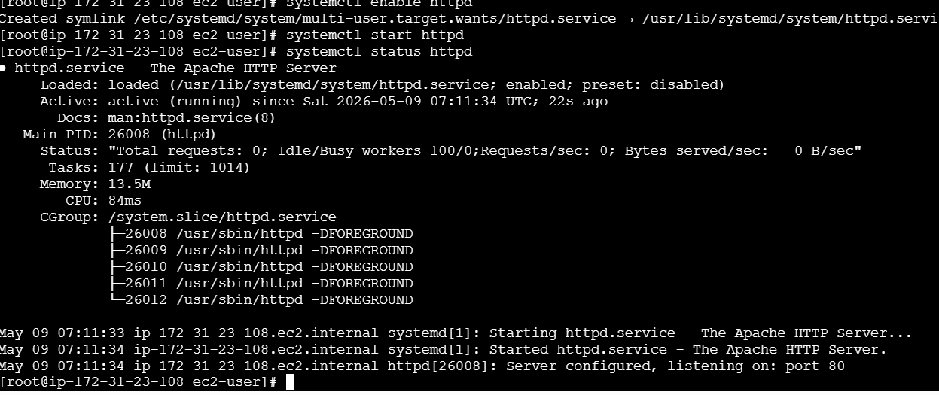
Verified in browser and its working
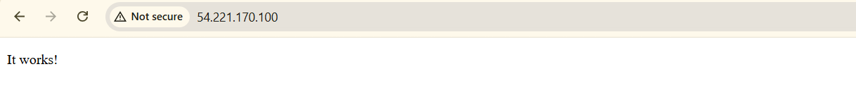

Go to target groups
Create target groups
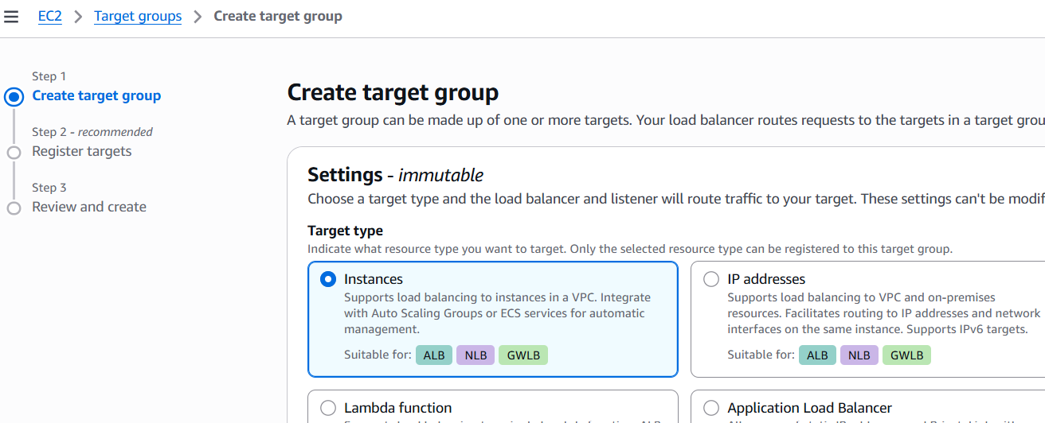
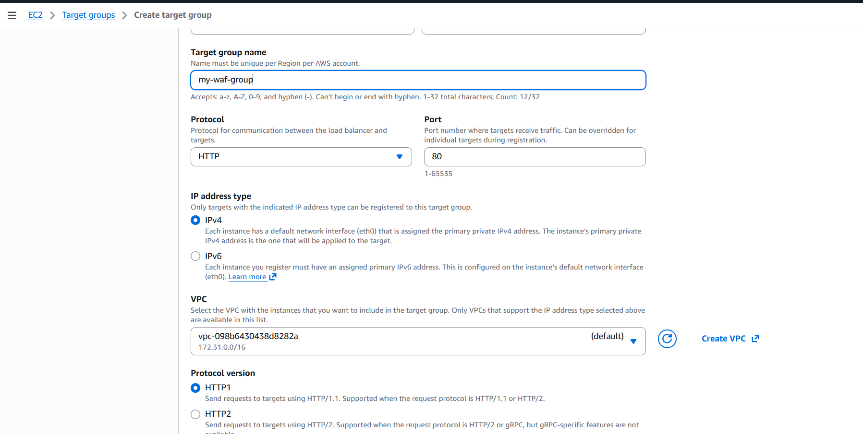
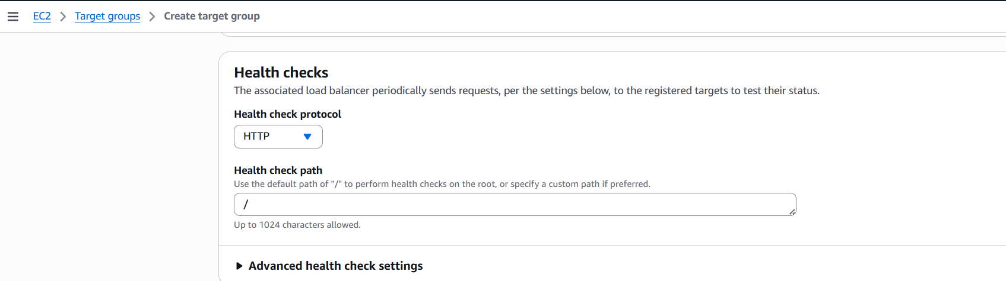
Register Target
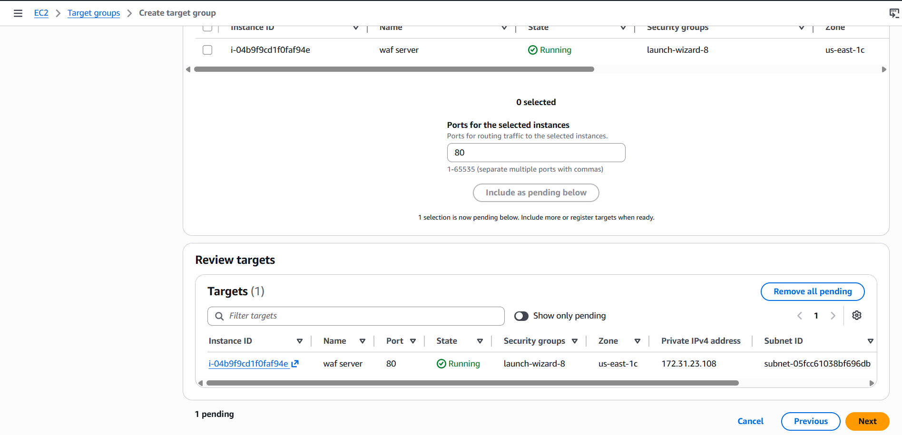
To check the health check
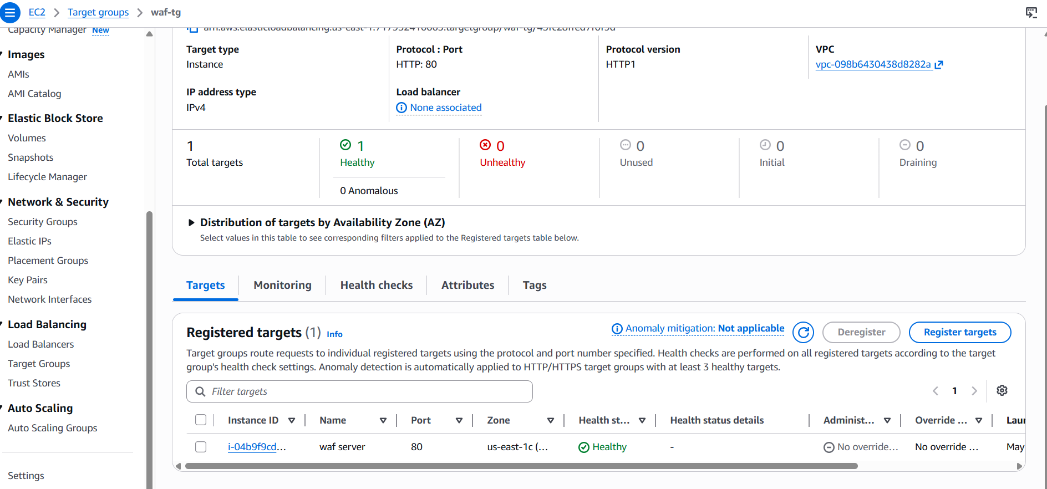
Then create load balancer
Name

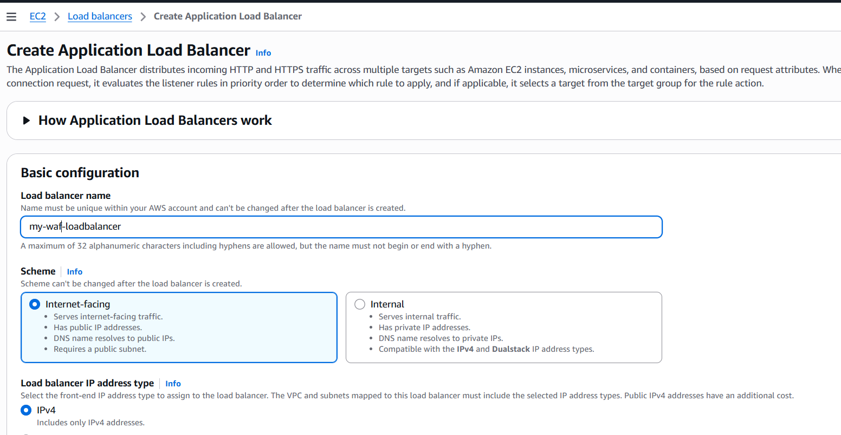
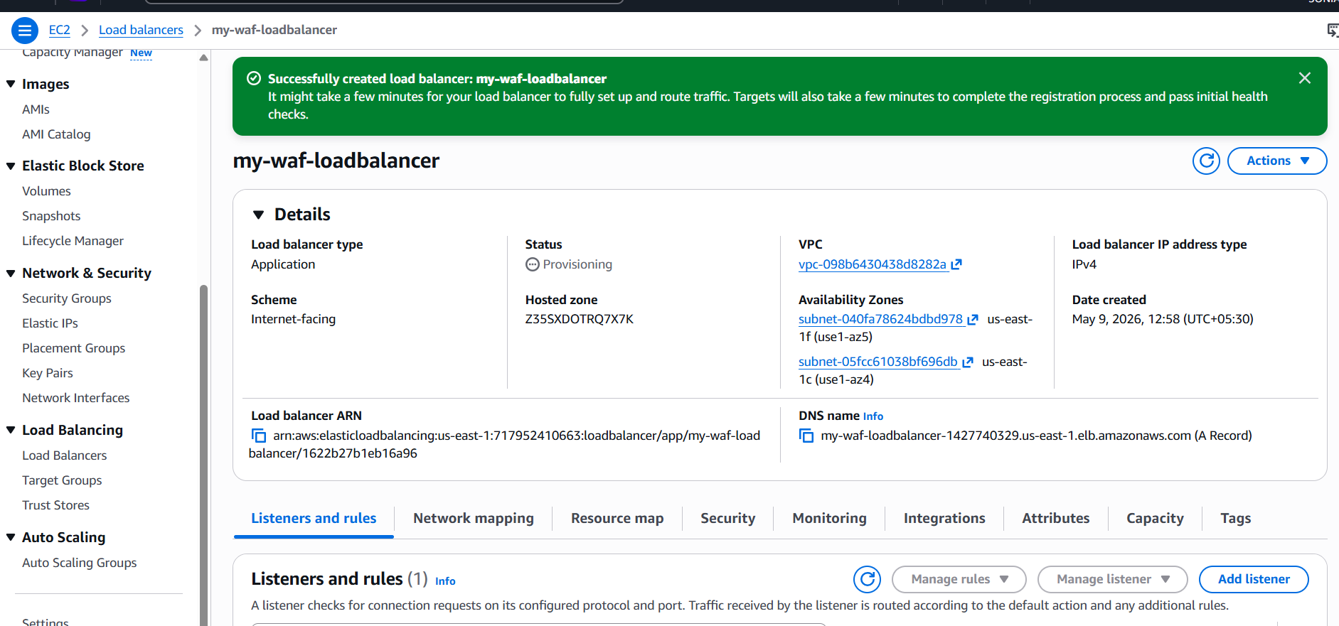
Load balancer is created
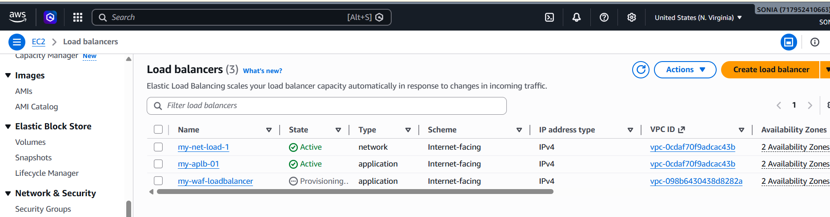

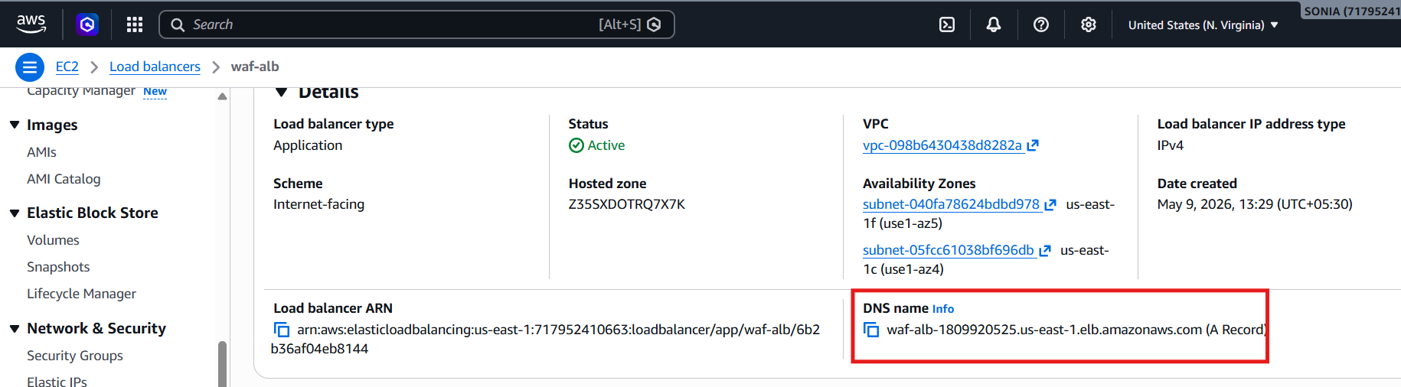
Verified in browser load balancer its working

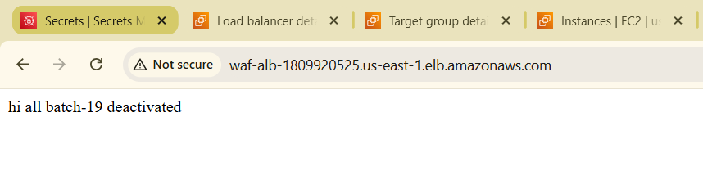
Create AWS WAF
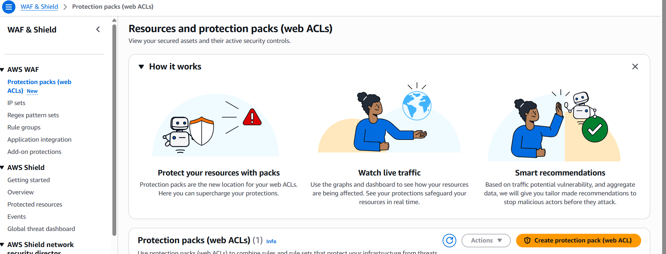
Select app category
e-commerce & transaction platforms
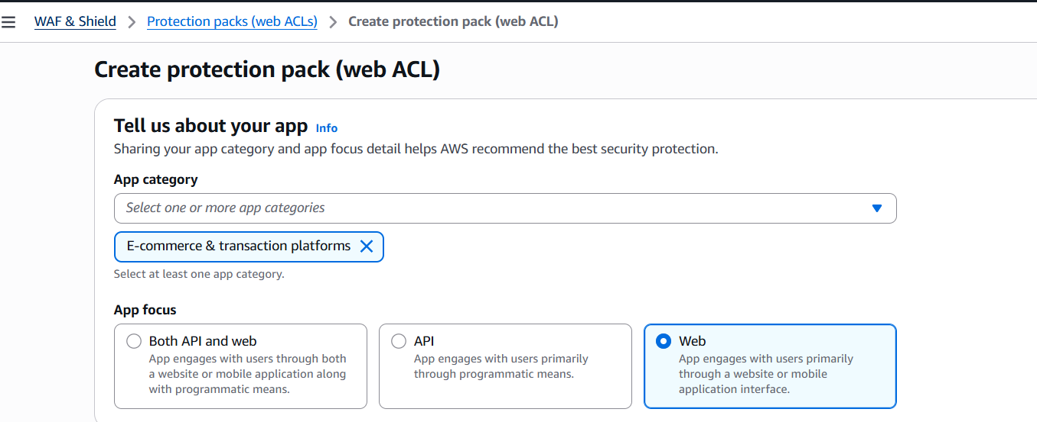
Add resources
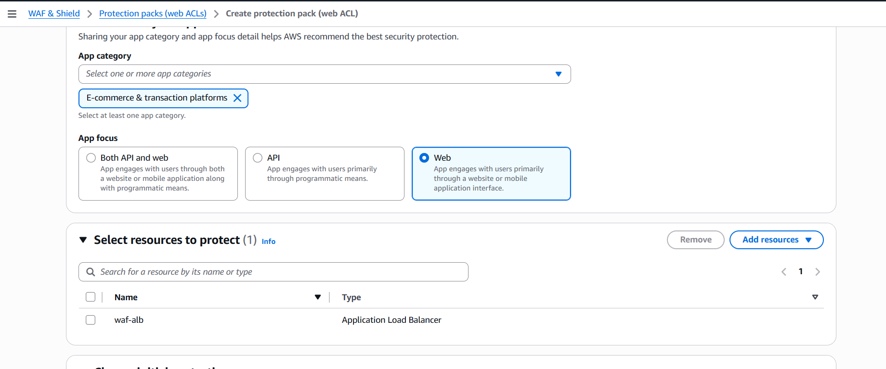
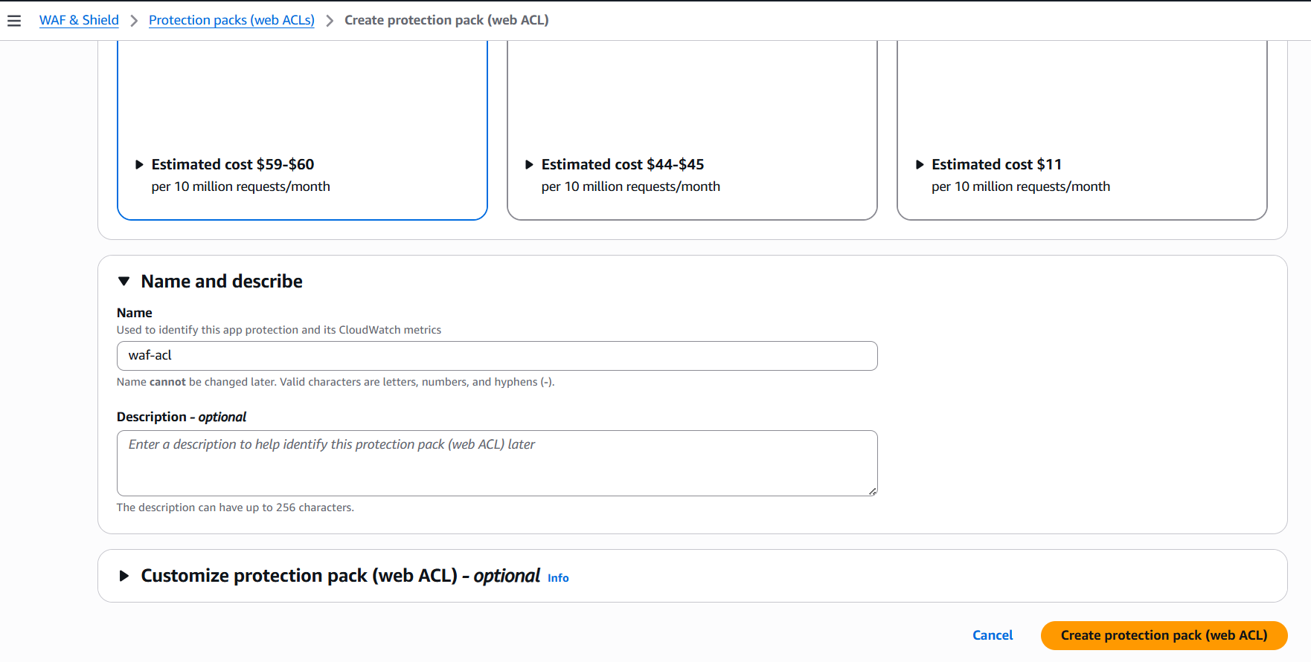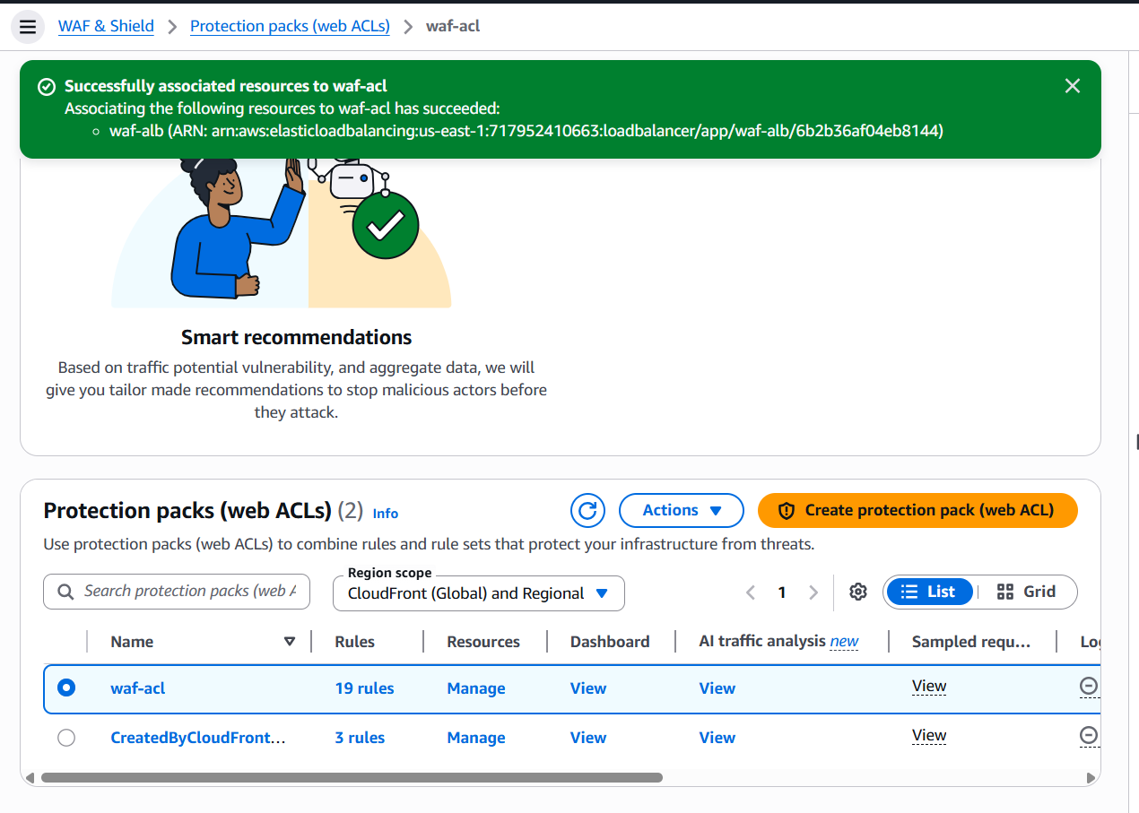
Created web acl

We are able to track the traffic
